Scan Photographs, Slides and Negatives
Equipment:
Epson V600 scanner and power cord
USB cord
Laptop and power cord
Mouse (optional)
Set up
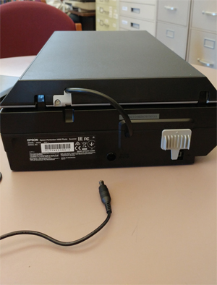
Plug in the scanner and the laptop
Grey Thingy

Move the grey locking thingy on the
back of the scanner towards the
center of the scanner
Hole for power cord

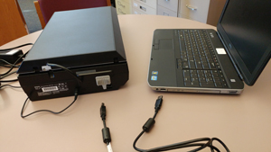
Plug one end of the
USB cable into the
back of the scanner,
and the other end
into the laptop

Turn on the laptop.

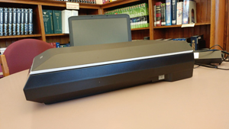
Turn on the scanner
On button
with the button on the
right side of the scanner

The scanner will blink and
beep after the laptop has
booted up.

On the laptop, click on the patron user’s icon and the type the password patron

The Basics

There are separate instructions for placing your originals for:
Photographs
Slides
Negatives (35mm)
Negatives (medium format)

Instructions for adjusting scanning details are independent of your image’s format.

Photographs | 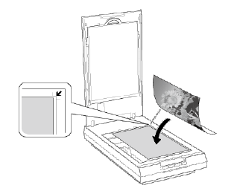  Photographs:  Place your photograph face down in  the upper right corner next to the arrow  You may scan more than one photo  at a time, just leave 20 mm (0.8”)  between photos  Jump to Scanning Instructions on Page 6

Negatives (35mm) | 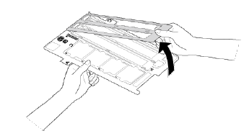  Negatives (35mm):  Position the film holder with the  narrow slots on the right.  Open the cover of the 35mm  film strip holder
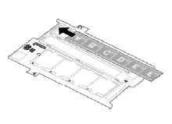
Hold the edges of the film

Place one or two film strips into the
film holder with the shiny side facing down.
The sky of the picture should be at the top
of the holder.
Slide the top of each strip under the clips

Your images should appear backwards

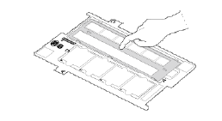
Put the small tabs on the top of the cover
into the film holder first.

Replace the cover and press the edges
until you hear it click all the way around

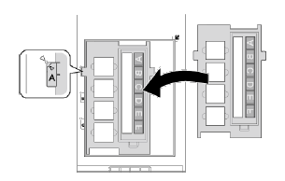
Place the film holder on the scanner glass
lining up the “A” tab on the holder with
the “A” tab to the left of the glass

Jump to Scanning Instructions
on Page 6

Slides | Slides:  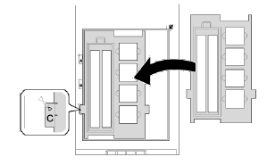  Place the film holder on the scanner glass  lining the “C” tab on the side of the  holder on top of the “C” location  at the left of the glass
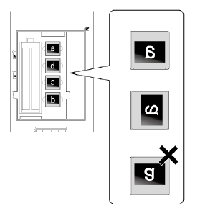

Place up to 4 slides in the film
Holder with the shiny side down.
Your images should appear
backwards.

The ground of the picture should be
Down or on the right hand side

Jump to Scanning Instructions on Page 6

Negatives (Medium Format - uncommon) |  | 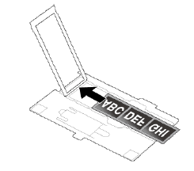  Negatives (Medium Format - Uncommon):  Ask for the film holder at the desk.  Open the cover of the medium format film  holder  Hold the film by the edges  Slide one medium format film image into  the film holder with the shiny side facing  down. Your images should appear backwards.
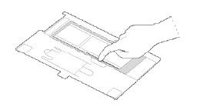

Replace the cover and press the edges
until you hear it click all the way around

If the film is curled, use the Scanning Support sheet. Leave 2mm space between the image frame and the support sheet.

Curled Downwards  Place the support sheet glossy side up under the film | Curled Upwards  Place the support sheet glossy side down over the film

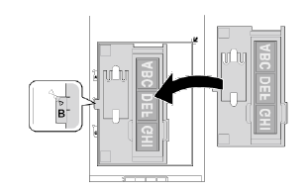
Place the film holder on the scanner glass
lining up the “B” tab on the holder with
the “B” tab to the left of the glass

Jump to Scanning Instructions on Page 6

Scanning your original (all formats)

Document Mat |  | For photographs, the document mat should be installed  For negatives and slides, the document mat should be removed  Photographs Make sure that the document mat is installed in the scanner cover Document Mat Negatives and Slides Remove the document mat by gently sliding it up 4 clips hold the document mat
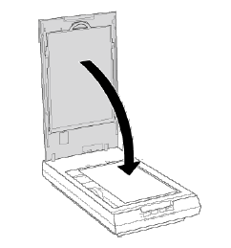
Close the scanner cover gently so that your
originals do not move

Double click the Epson Scan icon on the laptop

We recommend Home Mode or Professional Mode

Home Mode provides some Image
Adjustments and allows you to scan
more than one photograph at a time.
Click on the down arrow to see these choices

Professional Mode provides more specific
Image Adjustments, but allows only one
photograph at a time.

Both modes allow multiple slides and
negatives.

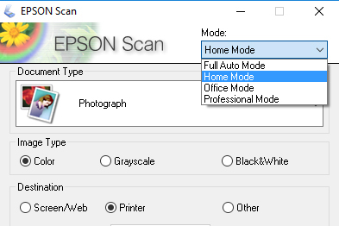
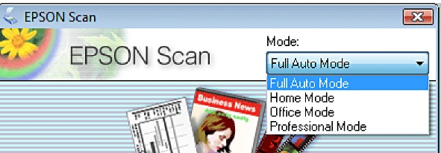

Choose the appropriate document type. Note that this looks different in Home Mode and Professional Mode

Home Mode

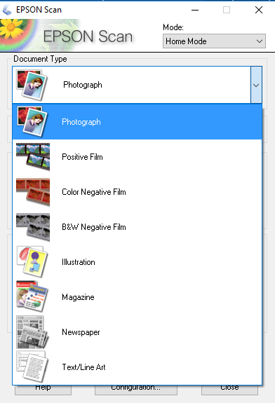

Photographs – Photographs

Slides – Positive Film
Click on the down arrow to see these choices

Negatives – Negative Film

If you are in Home Mode, go to page 9

Professional Mode

Photographs –  Reflective  Photo | Negatives –  Film  Color or B&W Negative Film  Slides –  Film  Positive Film

Next you need to decide how you will use the files you create of your pictures:

If you will ever want to print your photos, use 300 DPI
If you only want to view your photos on a computer, use 96 DPI

The Resolution is expressed in Dots Per Inch (DPI). A higher DPI means a more detailed image. Images that will be uploaded to the web are usually 96 DPI or 72 DPI. Images that will be printed are usually 300 DPI. If you will want to enlarge the image, you need to use more than 300 DPI – so that when you are finished enlarging it the resulting image will have 300 DPI.

Home Mode  Choose the destination to choose the resolution  Screen/Web = 96 DPI  Printer = 300 DPI  Other allows you to choose a different value for your resolution | Professional Mode  Choose the resolution on the main screen.

Optional |  | Image Adjustments help you to bring the best out in your photographs. Four adjustments are available in both Home mode and in Professional Mode:  Descreening Removes the rippled pattern that can appear in subtly-shaded image areas, such as in skin tones. Also improves results when scanning magazine or newspaper images which include screening in their original print processes.  Color Restoration - Restores the colors in faded photos automatically.  Backlight Correction - Removes shadows from photos that have too much background light.  DIGITAL ICE Technology - Remove dust marks that the Dust Removal feature cannot. DIGITAL ICE Technology takes longer to scan and also uses more of your system resources.
Optional | Home Mode has a Brightness button which allows adjustment of both brightness and contrast
Professional Mode adds the ability to tune those adjustments as well as two new adjustment options:

Unsharp Mask - Turn on to make the edges of image areas clearer for an overall sharper image. The level of sharpness is adjustable. Turn off to leave softer edges.
Dust Removal - Removes dust marks from your originals automatically. The results of Dust Removal do not appear in the preview, only in your scanned image. The level of dust removal is adjustable.

Additionally, five icons are available for more detailed adjustments:

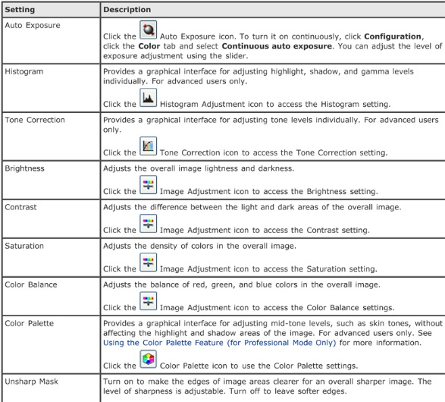

Click the Preview button to see the image that will be saved

Home Mode | Professional Mode

Optional | If you want to crop the image you can hover your mouse over the image. When the cursor becomes a large Plus Sign (+) click and drag to choose the area you wish to scan. If your cursor does not become a large Plus Sign, try clicking the Marquee tool button to cancel a previous selection.  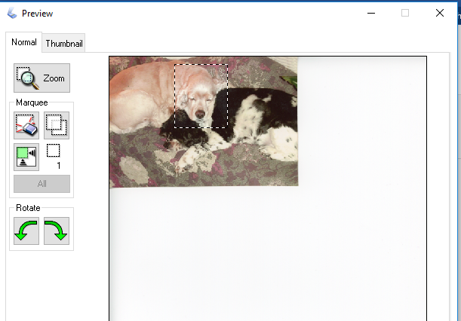  Cancel previous Marquee selection
Choose Scan to perform the scan.

Home Mode | Professional Mode

These are the default values:
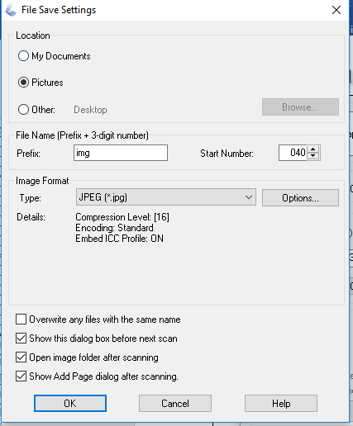
The File Save Setting box lets you choose:

Location – where will your files be saved

File name – Typically, you choose a prefix for
The file name and consecutive numbers are
Assigned to each image. For example, if your
Prefix is “img” and your start Number is 040
Then the next images will be called img040,
Img041, img042 etc.

Image format – JPG, Bitmap, TIFF, PDF

When you click the OK box, the scan is run.

When you have finished scanning, copy your files to a thumb drive or save them in Google Docs, Dropbox or another cloud location. Thumb drives are available for purchase at the Circulation Desk for $10.

The default location for the pictures is the Pictures folder. You can select all of the pictures with Control-a. Then click and drag them all at once.

Please delete your pictures from our laptop.

Please choose Configuration and reset the setting to their default values on the “Other” tab of the Configuration box by clicking the “Reset All” button.
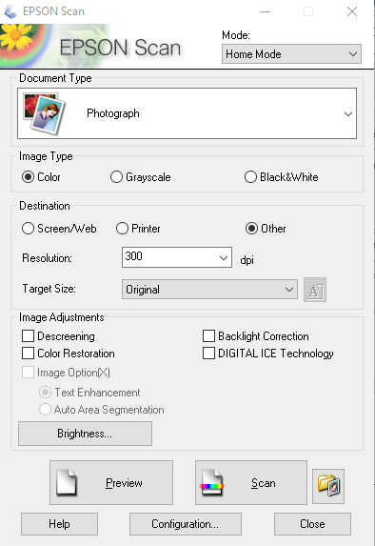
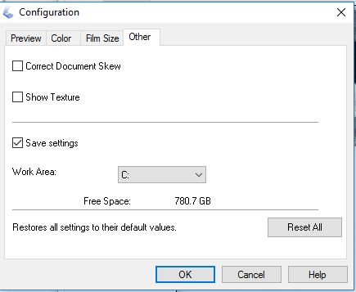

Other

Reset All
Configuration

Please replace the Document Mat white side out if you scanned either negatives or slides

Turn off the laptop
Turn off the scanner on the right hand side

Please unplug the USB cable
and then move the grey thingy on the
back of the scanner into the locked position
by sliding towards the side of the scanner
before you move the scanner.

