How to convert your DVD to .mp4 files
Go to https://handbrake.fr/
Download Handbrake and install it on your computer.
It is already installed on our Makerspace Laptops

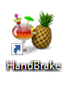

Double click the handbrake icon

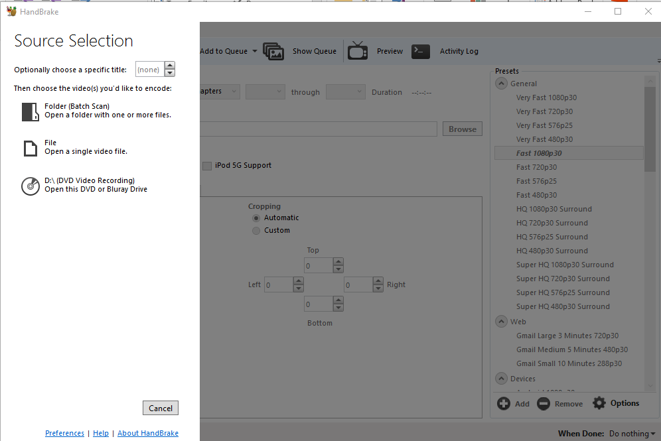

To convert the entire DVD, choose d:\ (DVD Video Recording)

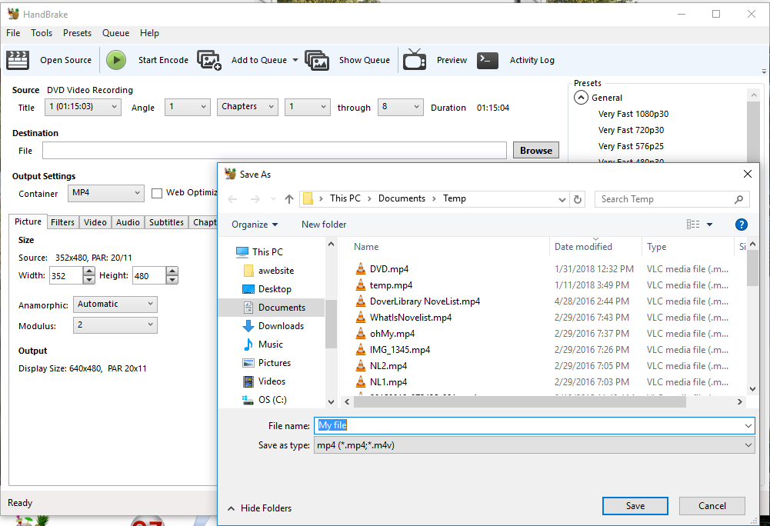

Click on the Browse button and choose a filename and where you want to save your file
Make sure the Output Setting is MP4

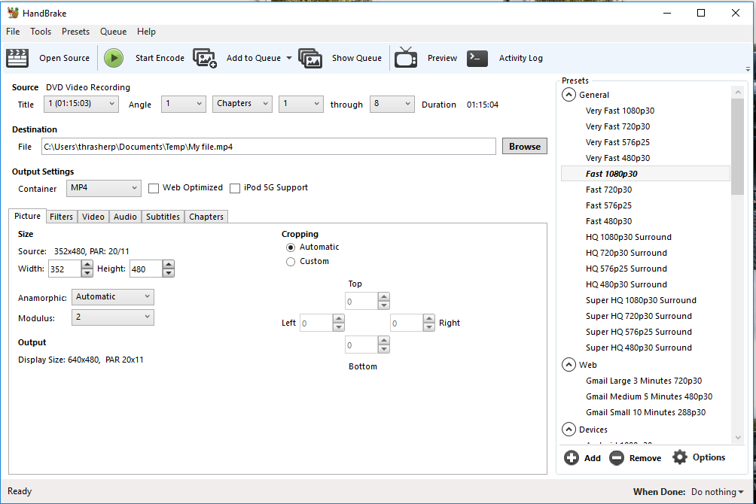

Click on the green Start Encode button

