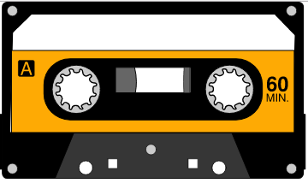
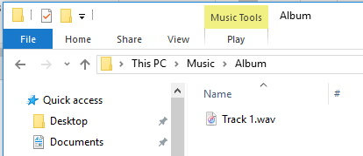
Convert cassette tapes to .WAV files

Equipment:
Tape2PC Converter
USB cord
Laptop and power cord
“Y” headphone cable
Mouse
The quality of the recording is not guaranteed. Please remember that cassette tapes degrade over time, and the quality of the original cassette tape was not the quality that we expect today.

Copying is done in real time – a one hour cassette tape will take one hour to copy. Make sure you will finish before the library closes!

Plug in the Laptop

Plug in the Tape2PC converter

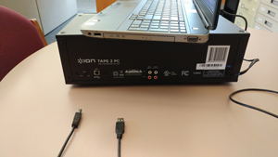
Plug USB cable into laptop and
the back of the Tape2PC converter

(the connector will look like it isn’t plugged in
all the way at the Tape2PC converter)

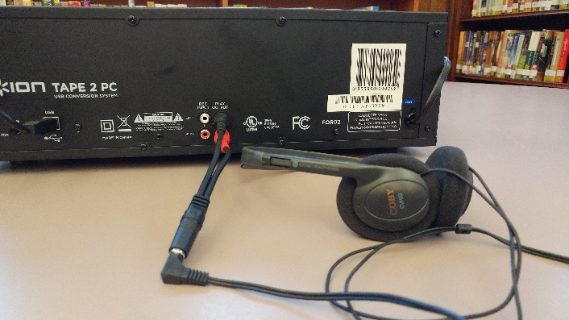
You can listen while you copy by plugging in
the red and black ends of the “Y” cable into
the Play Output connectors on the back of
the Tape2PC converter. Plug your headphones
into the other end of the “Y” cable. We have
earbuds for sale at the circulation desk if you
need them.

Headphones

Turn on the laptop

Click on the patron user’s icon and the type the password patron

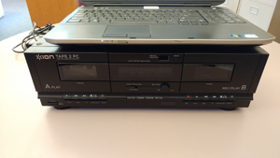
Turn on Tape2PC converter

Power button

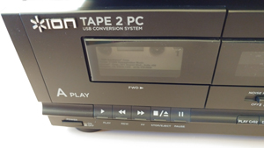
Open the A deck of the Tape2PC converter
Open
(Stop)

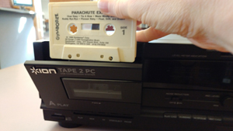
Load your cassette tape into the A deck.

The tape should be on the bottom of the cassette.
The side that you will record will be facing you, and
the tape should be on the left reel when the cassette
is cued at the beginning.

If the door doesn’t close, take the tape out and put
it back in. Don’t push the tape in too far.

Double Click EZ Vinyl-Tape Converter icon on the laptop

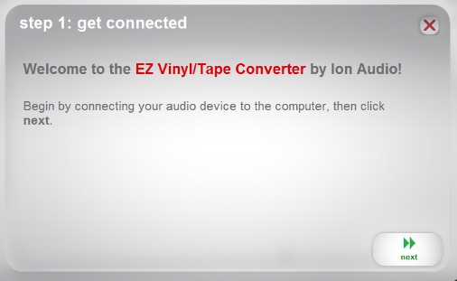
Click Next

Click Record on the laptop and firmly press the play button on the A deck at the same time.

The red dot in the record button will turn into green arrows.
The play button will click and stay pushed in.

Play

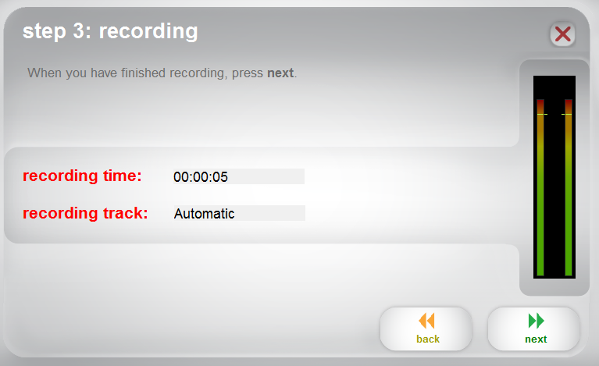
When you have finished recording:

Click Next on the laptop to stop the recording, push
the stop button on the tape player, too.

If you record the entire side of a cassette,
it will record each track in an individual file.
when the cassette ends, the recording will end
by itself.

Name the Artist, Album, and Track title

You can change the save location by clicking on the folder icon.

If you do not enter this information, the files will be saved with generic names (i.e. Track 1.wav).

Click Next to save the files

Folder icon

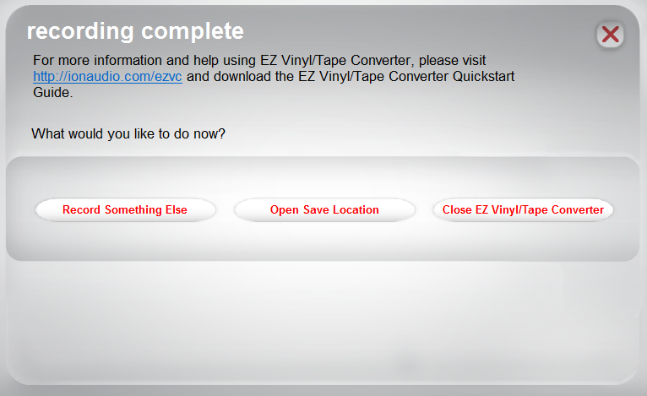
Continue recording,

OR

See what you have saved by Opening
the Save Location,

OR

or exit the software by Closing the
EZ Vinyl/Tape Converter

If you saved your files on the laptop, please transfer them to a USB drive (you can purchase one at the library), or to cloud storage.

The default location for the files on the computer is the Music folder

Please delete any files from our laptop.

Make sure to take your cassette.

Turn the laptop off.
Turn the Tape2PC converter off.

If you want to convert your .wav tapes to .mp3s, you can use Audio Converter by MediaHuman at http://www.mediahuman.com/audio-converter/

.mp3 files are much smaller than .wav files, but have less fidelity.

