Who Are the Friends?
The Friends of the Library are ordinary people like you and me who care about libraries and are interested in promoting and enhancing library resources.

Friends are people who know that any community is a better place to live if that community has a first-rate library which serves its needs and interests.

Our Goals
- Create public support and good public relations for our library;
- Encourage all citizens’ use of the library and its services;
- Sponsor programs that contribute to Dover’s educational and cultural life;
- Encourage gifts, endowments and memorials.

We can only achieve our goals with your support.

Established in 1977
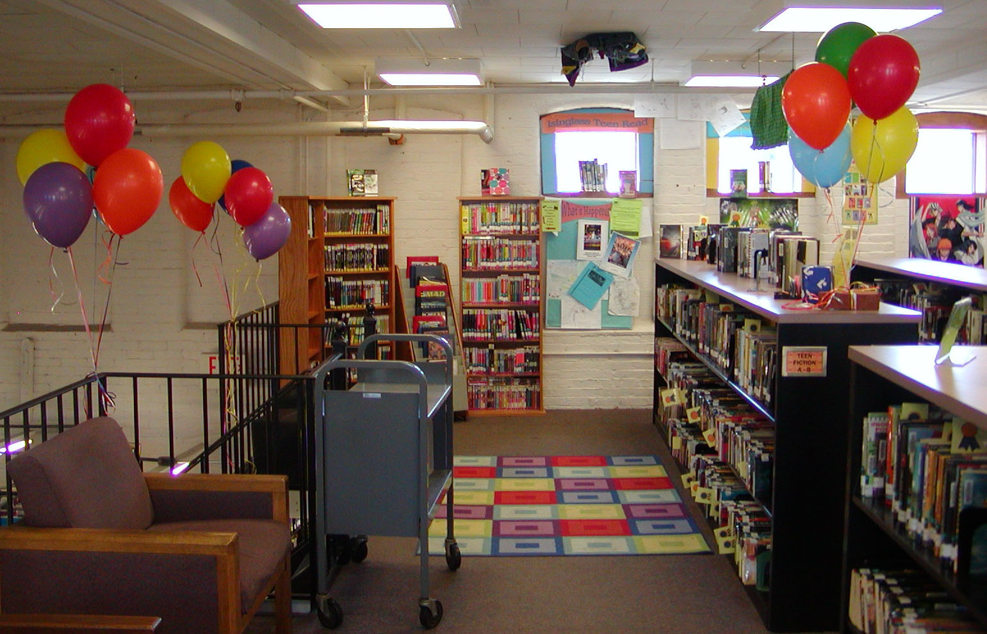
Since our inception in 1977, the Friends of the Dover Public Library have raised thousands of dollars for…
- Library equipment and signage,
- Computers,
- Furnishings,
- Annual passes to local and regional museums.

The Friends have sponsored countless educational and cultural programs, slide shows, concerts and authors’ visits.

Additionally, we sponsor the library’s ongoing book sale and annual fall book sale.

Everyone needs a friend, even your library. Won’t you join us?

You can give as little or as much time as you want. You can participate once a year or be active throughout the year.

We welcome any contribution you can make.
Friends of the Dover Public Library
Member Application

_______________________________
Name
_______________________________
Mailing Address
_______________________________
City, State, Zip
_______________________________
Phone
_______________________________
E-Mail

Type of Membership:
 Individual $15.00
 Senior (62 or older) $10.00
 Sponsor $30.00
 Lifetime $200.00

I am able to help with…
- Graphic design
 Publicity
 Grounds beautification
 Fundraising
- Program planning
- Book sales
- Database management
 Special talents or services to offer:
_______________________________
_______________________________

 I am glad to support the Friends but wish to be an inactive member.

Thank You for Your Support!
Upcoming Meetings
All meetings take place at 6:30pm in the Trustees Room.

January 14, 2020

March 10, 2020

May 12, 2020

September 8, 2020

November 10, 2020

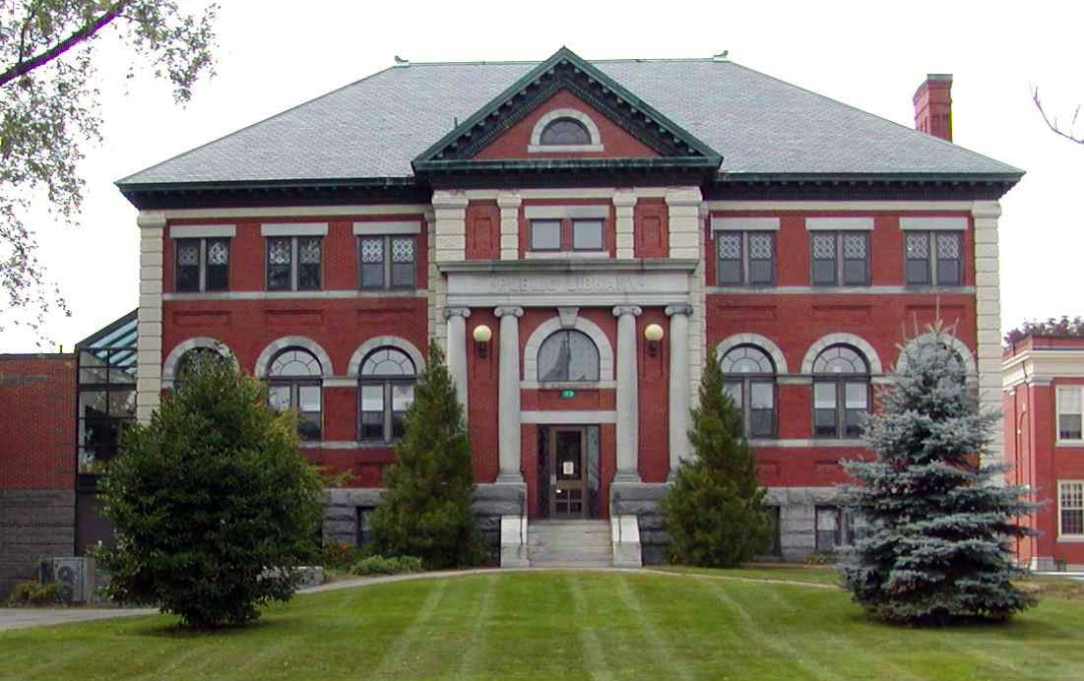

The Friends of the Dover Public Library is a 501(c)(3) non-profit organization and donations are tax-deductible.
Welcome to Our Monthly Meetings!
Friends of the Dover Public Library
The Friends of the Library meet 5 times yearly, on the 2nd Tuesday of the months of January, March, May, September and November at 6:30pm.
Friends Corner &
Continuous Book Sale
Library-themed merchandise (canvas book bags, Dover notecards and maps, etc.) is for sale in the Friends’ Corner near the main desk. Like-new books are sold year-round at the Continuous Book Sale in the public computer room.

Dover Public Library Online
Main Website:
http://library.dover.nh.gov
Library Blog:
http://doverpl.blogspot.com
Facebook:
http://www.facebook.com/DoverPLNH
Twitter:
http://twitter.com/dplnh
Instagram:
http://instagram.com/doverpubliclibrary
Pinterest:
http://pinterest.com/doverpl
Historic Dover Photographs:
http://images.library.dover.nh.gov
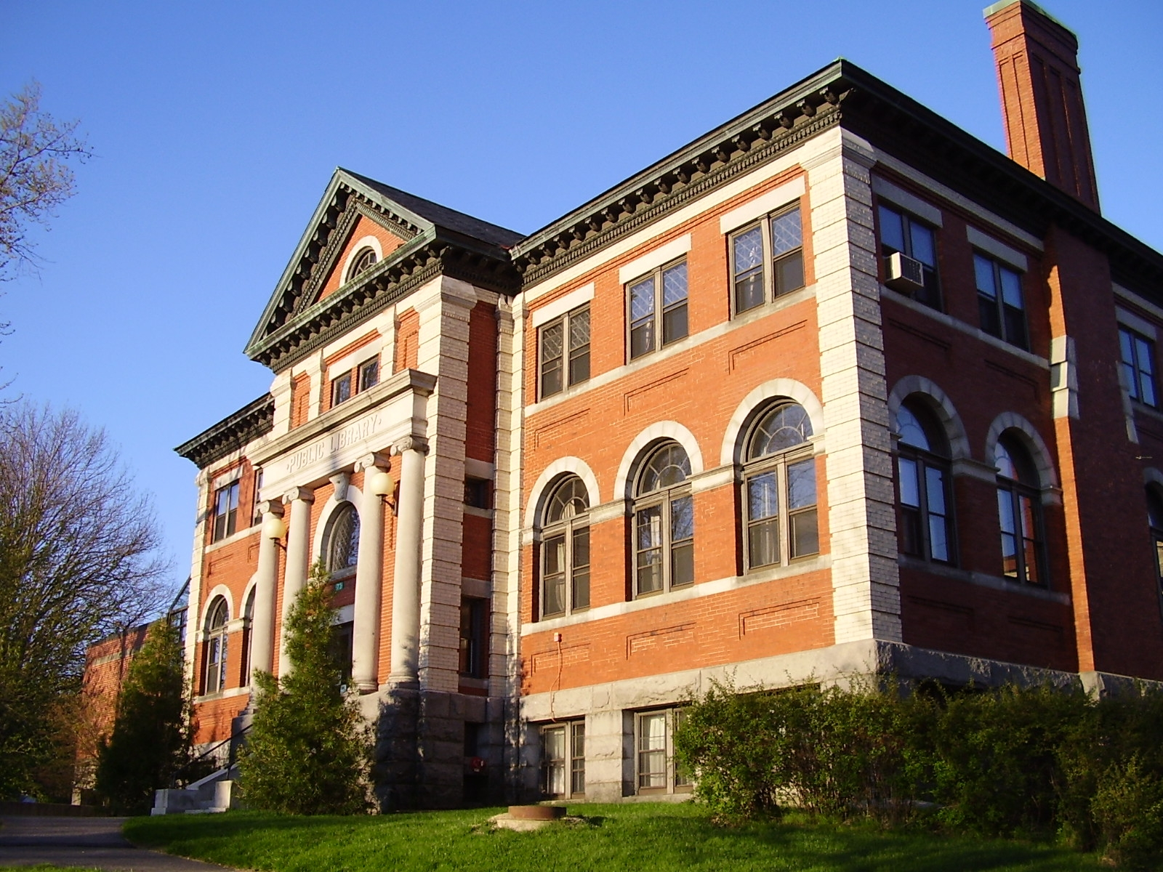
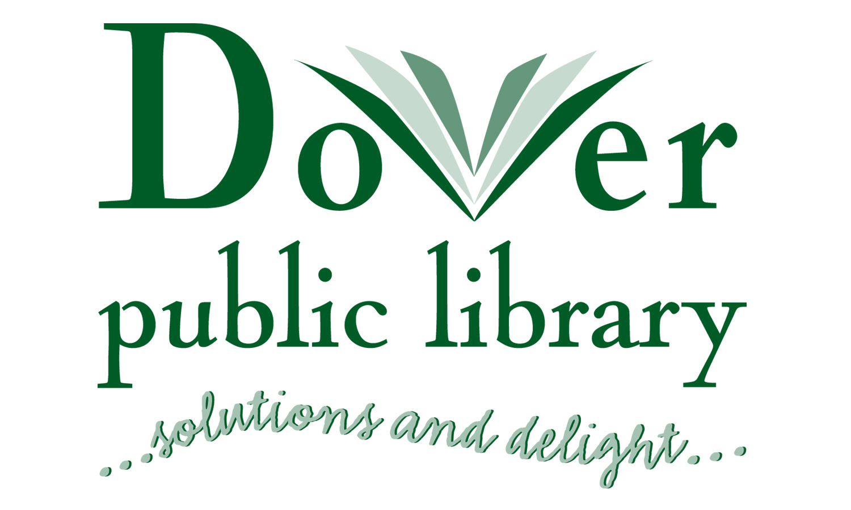

73 Locust Street
Dover, NH 03820
http://library.dover.nh.gov

Main Desk:
(603) 516-6050

Children’s Room:
(603) 516-6052

Reference:
(603) 516-6082

FAX: (603) 516-6053

Email: friendsofthedovernhlibrary@ gmail.com

